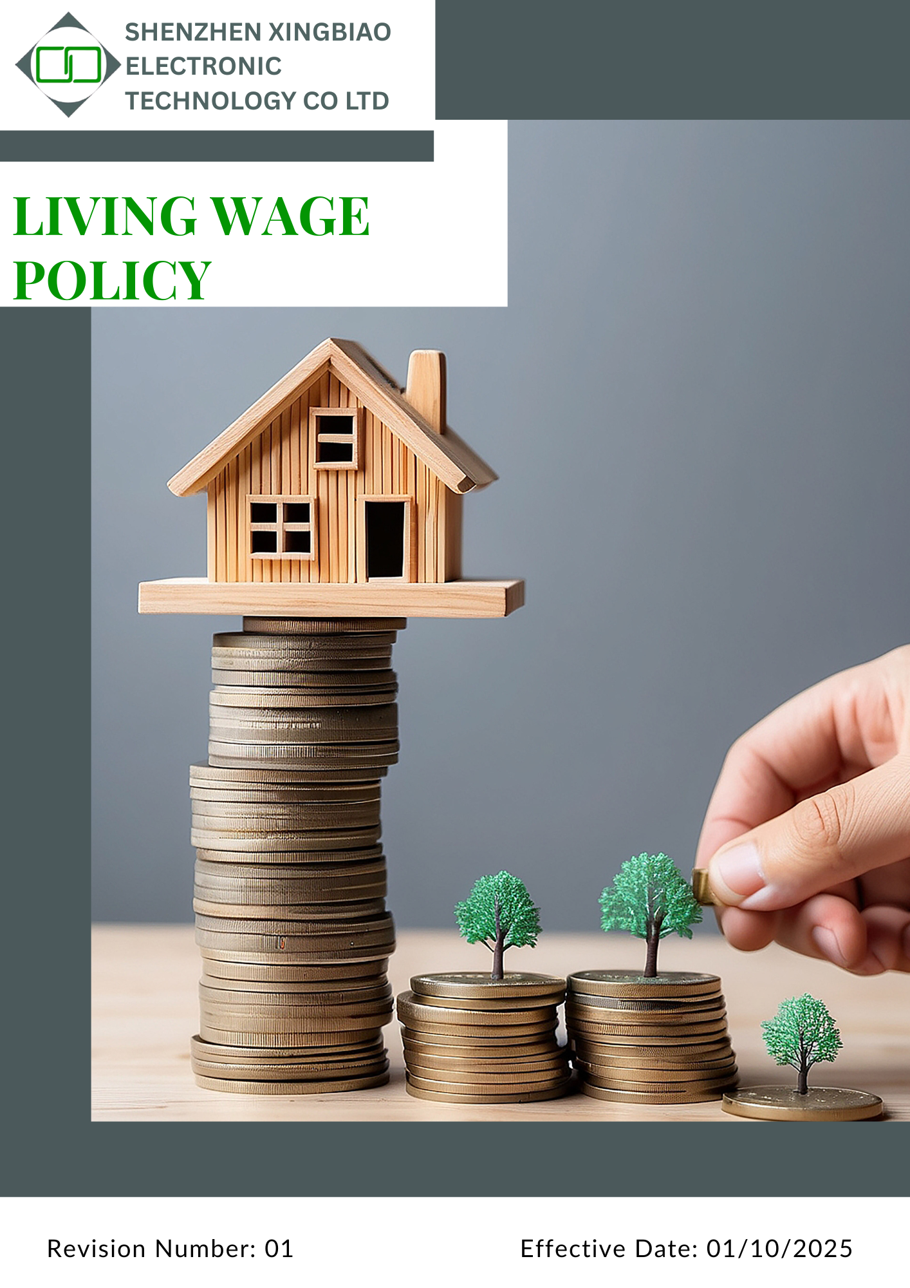
Table of Contents
1. INTRODUCTION 3
2. SCOPE 3
3. POLICY STATEMENT 3
4. QUALITATIVE TARGETS 3
5. QUANTITATIVE TARGETS 4
6. RESPONSIBILITIES 6
7. REPORTING MECHANISM 6
8. COVERED SDGs 7
9. REVIEW MECHANISM 8
10. EMPLOYEE ACKNOWLEDGEMENT FORM: 9

INTRODUCTION
At Shenzhen Xingbiao Electronic Technology Co Ltd, we recognize that fair wages are fundamental to employee well-being and economic stability. A living wage ensures that employees earn enough to meet their basic needs, including housing, food, healthcare, education, and savings. Our commitment to providing a living wage aligns with our dedication to social responsibility, employee welfare, and ethical business practices. By implementing a structured living wage framework, we aim to foster financial security, job satisfaction, and long-term sustainability in our workforce.

SCOPE
This policy is applicable to all employees, workers, subcontractors, and other stakeholders directly affiliated with us. The applicable all sites are:

Location Name | Address
Shenzhen Xingbiao Electronic Technology Co Ltd | Floor 1-4, Building No.13, Antuoshan High-tech industrial Park, Shajing Sub-district, Bao'an District Shenzhen 518000 Shenzhen, Guangdong China

POLICY STATEMENT
Shenzhen Xingbiao Electronic Technology Co Ltd is committed to ensuring that all employees earn at least a living wage, which exceeds minimum wage requirements and reflects the actual cost of living. We will conduct periodic wage assessments, adjust compensation structures accordingly, and work with suppliers to promote fair wage practices across our value chain. Our commitment to fair wages contributes to employee well-being, increased productivity, and long-term business success.

QUALITATIVE TARGETS
- Fair Compensation
  - Promote regular internal reviews to align compensation with industry standards and employee well-being.
  - Foster a workplace culture where every employee receives fair and dignified compensation.
  - Ensure comprehensive benefit offerings including healthcare, retirement plans, and paid leave for all full-time staff.
  - Maintain a transparent and structured salary increase framework reflecting company performance and market conditions.
- Living Wage Implementation
  - Ensure wages are fair, competitive, and aligned with locally applicable living wage benchmarks.
  - Integrate living wage principles into compensation planning, salary reviews, and workforce management.
  - Promote wage progression linked to skills development, experience, and performance.
  - Periodically review wage practices to maintain alignment with cost-of-living changes.
- Wage Transparency
  - Strengthen awareness of compensation policies and pay structure among all management and HR teams.
  - Encourage open communication around pay structures and benefits during on boarding and performance reviews.
  - Integrate wage transparency principles into training modules and employee engagement programs.
- Supplier Engagement
  - Support key suppliers in adopting responsible wage practices aligned with industry expectations.
  - Engage suppliers in dialogue and capacity-building around living wage implementation best practices.
  - Recognize suppliers that demonstrate leadership in fair compensation practices.
- Wage Equity & Non-Discrimination
  - Promote equal pay for work of equal value, with adjustments based on performance, behavior, and experience.
  - Establish a proactive review mechanism to identify and address wage equity opportunities across the workforce.
- Transparency and Communication
  - Promote clear and transparent communication regarding wages, benefits, and payroll processes.
  - Ensure employees have access to accurate and timely wage-related information.
  - Periodically communicate progress on living wage commitments to employees and relevant stakeholders.
  - Maintain accessible and confidential channels for employees to raise wage-related questions or concerns.
  - Commit to continuously paying wages that meet or exceed applicable living wage standards, with periodic reviews to ensure alignment with local cost-of-living conditions.

QUANTITATIVE TARGETS
The year 2022 serves as the established baseline for comparison.

    - Fair Compensation
  - Maintain 100% of employees earn at least the local living wage by 2030.
  - Ensure 98% of full-time employees have access to healthcare, retirement, and paid leave benefits by 2030.
  - Implement a standardized salary revision framework by 2030.

    - Living Wage Implementation
  - Ensure 100% of direct employees receive wages that meet or exceed applicable living wage benchmarks by 2030, using locally adjusted living wage calculation methodologies.
  - Extend living wage requirements to cover at least 60% of Tier 1 suppliers by 2030.
  - Implement a wage progression framework that enables employees to reach up to 120% of the living wage within three years of employment, where applicable.
    - Wage Transparency and Communication

  - Ensure 100% of senior management and HR staff are trained in compensation and wage equity policies by 2030.
  - Ensure wage policy materials are shared with 100% of new hires during on boarding by 2030.
  - Conduct annual awareness sessions on wage structure and benefits, reaching 100% of employees by 2030.
  - Implement a digital payroll system providing individual employee access for 100% of the workforce by 2030.
  - Publish an annual wage and living wage progress report covering 100% of employees by 2026.
    - Supplier Wage Standards
  - Ensure 100% of key supplier agreements include fair wage expectations by 2030.
  - Conduct wage assessments with at least 85% of key suppliers by 2030.
  - Facilitate fair wage planning with 70% of key suppliers by 2030.
    - Wage Equity & Non-Discrimination
  - Reduce identified wage gaps by 35% by 2030, considering performance, behavior, and experience through structured adjustments.
  - Conduct company-wide wage equity reviews at least once annually, with 100% department-level coverage by 2030.
    - Transparency and Communication
  - Promote clear and transparent communication regarding wages, benefits, and payroll processes.
  - Ensure employees have access to accurate and timely wage-related information.
  - Periodically communicate progress on living wage commitments to employees and relevant stakeholders.
  - Maintain accessible and confidential channels for employees to raise wage-related questions or concerns.
  - Commit to continuously paying wages that meet or exceed applicable living wage standards, with periodic reviews to ensure alignment with local cost-of-living conditions.

RESPONSIBILITIES
At Shenzhen Xingbiao Electronic Technology Co Ltd, a structured governance framework ensures effective implementation, monitoring, and continuous improvement of fair wage practices across the organization and supply chain.
- Executive Leadership Team:
  - Approves fair wage policies, ensuring alignment with business values and sustainability commitments.
  - Oversees implementation and integration of living wage practices.
  - Reviews progress on wage equity and key supplier compliance, making necessary adjustments

- HR & Procurement Teams:
  - Ensure compliance with living wage standards and industry benchmarks.
  - Conduct wage audits and maintain fair pay structures across employees and key suppliers.

- HR, Finance & Compliance Officers:
  - Analyse financial sustainability of wage structures and ensure legal compliance.
  - Identify improvements.

- Managers:
  - Adhere to wage policies, support employees, and uphold fair wage principles.

- Suppliers:
  - Adhere to fair wage policies, comply with contracts, and cooperate in audits.
  - Ensure compliance with fair wage standards as outlined in procurement agreements and supplier contracts.
This governance structure promotes accountability, equity, and continuous wage improvements.

REPORTING MECHANISM
Shenzhen Xingbiao Electronic Technology Co Ltd maintains a transparent and structured wage reporting and monitoring framework to track progress and ensure accountability. Key elements include:

- Wage assessment:
  - Conduct comprehensive periodic wage assessments, including a breakdown of wage distribution, adjustments, and employee benefits enhancements.
  - Conduct and review insights into wage structure changes, supplier compliance status, and the implementation of corrective actions.
  - Ensure all wage-related data is compiled in compliance with regulatory requirements and shared with relevant stakeholders.

- Supplier Compliance Audits:
  - Conduct periodic key supplier audits to assess adherence to fair wage standards, with a focus on wage payments, benefits, and working conditions.
  - Establish a structured corrective action plan process to address non-compliance, with regular follow-ups and progress tracking.

- Employee Feedback & Grievance Mechanisms:
  - Maintain confidential reporting channels, to include some combination of online portals, and direct HR access, Sr. Management access to allow employees to raise wage-related concerns.
  - Adhere to our resolution process to address employee grievances promptly, ensuring transparency and fair handling of all wage-related concerns.

COVERED SDGs


REVIEW MECHANISM

The Head of HR will review this policy annually to ensure its effectiveness and compliance. Updates will be shared with stakeholders, and the company may revise the policy as needed to address regulatory or operational changes.

Signature:
Approved By:
Designations:
Next Review Date: 01-10-2026

EMPLOYEE ACKNOWLEDGEMENT FORM:
At Shenzhen Xingbiao Electronic Technology Co Ltd, we are committed to providing fair and equitable compensation by ensuring all employees receive a living wage that supports a decent standard of living. We believe that every employee deserves wages that meet basic needs and promote dignity, security, and well-being. This commitment reflects our core values of fairness, respect, and social responsibility across all levels of our operations.
By signing this form, I agree to:
- Comply with the company’s Living Wage Policy and related compensation practices.
- Treat wage-related information with transparency and integrity.
- Report any concerns or inconsistencies in wage practices to the HR department.
- Support efforts that promote fair pay, equality, and decent working conditions for all employees.

Employee Confirmation:
Employee Name:
Designations
Signature:
Date:

